Wind energy is a clean, renewable form of energy that has many pros. Learn more below.

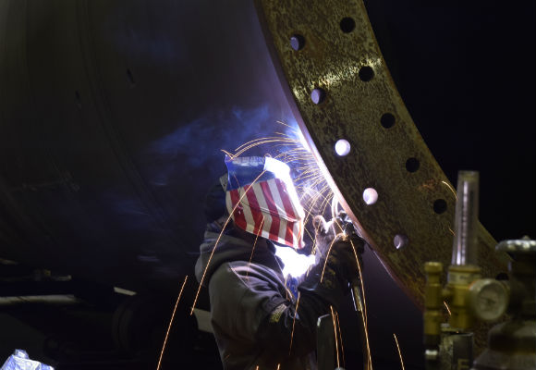

Winds Powers Job Growth

American wind energy is a major job creator-- today over 114,000 U.S. workers(Opens in a new window) now have wind-powered careers.

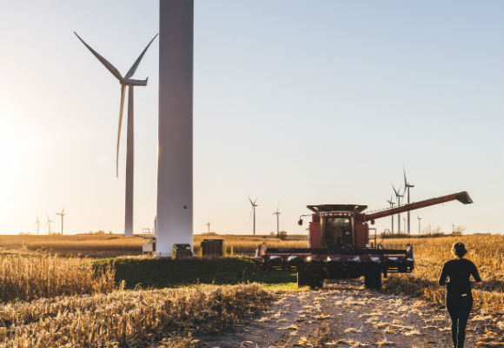

Economic Development

U.S. wind power drives unmatched economic development(Opens in a new window) into rural America.

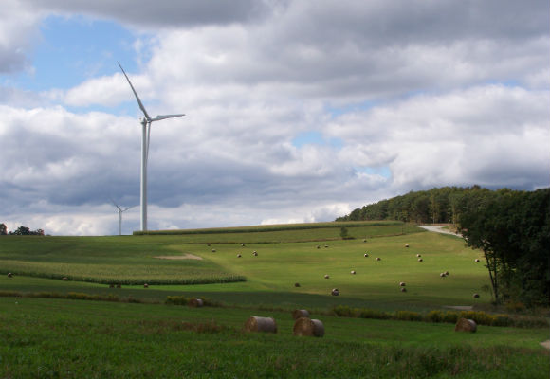

Environmental Benefits

Wind power has some of the lowest environmental impacts of any source of electricity generation.

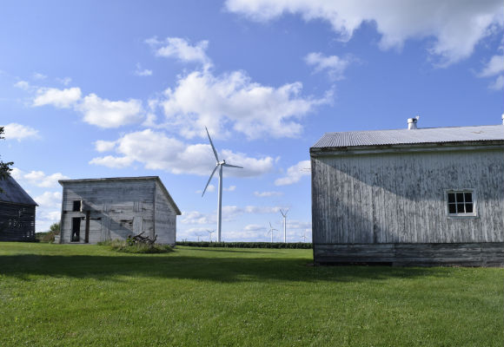

Wind In My Community

Read through the Benefits of Wind Energy section, and then read more on specific topics like agriculture, property values, and living near turbines.